教师电脑实名认证上网教程
- 电脑开机后打开浏览器。打开暨南大学主页https://www.jnu.edu.cn，浏览器会弹出认证页面。
Power on the computer then visit https://www.jnu.edu.cn in a browser to pop up the authentication page.
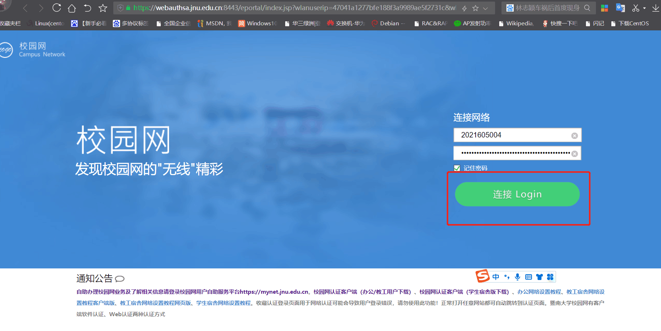
2. 输入您的JNUID账号和密码后，点击登录，出现“已成功接入网络”的提示页面，说明您已经正常连接并认证成功，可以正常上网。
After entering your JNUID and password, click Login, and the prompt page of “Login Success” will appear, indicating that you have been connected to the Internet.
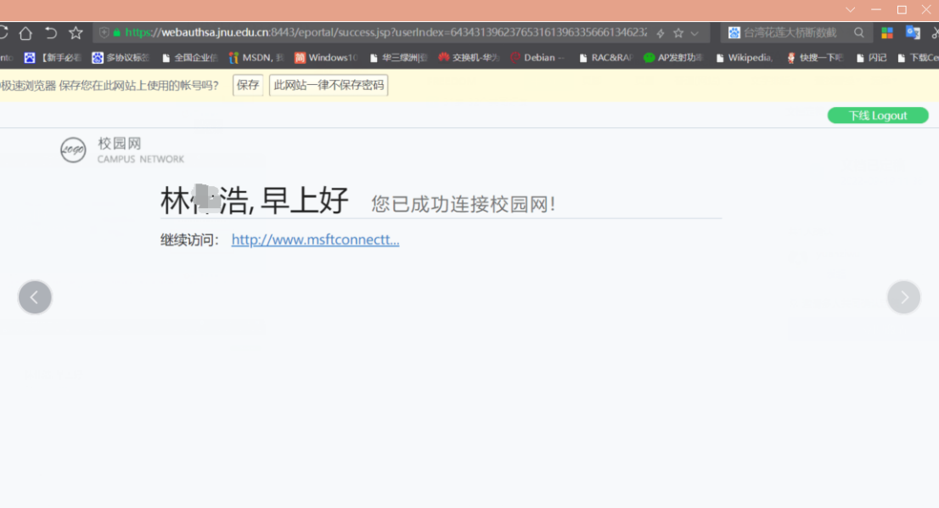
3．若您忘记JNUID的密码，请您打开浏览器，输入 https://mynet.jnu.edu.cn/app，点击右下角的“忘记密码”进行密码修改。
If you forget your JNUID password, please visit https://mynet.jnu.edu.cn/app and click "Forgot Password" in the lower right corner to change your password.

4.课程结束后，请您关闭所有浏览器，系统将自动退出上网认证。如需继续访问互联网，请打开浏览器重新认证。
After the course, please close all browsers to log off.

